B.H COLLEGE,HOWLY, BARPETA,ASSAM-781316 DEPARTMENT OF POLITICAL SCIENCE
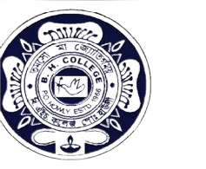
Departmental seminar
Organized by
The Department of Political Science

Name of the Activity | Date | Venue | Volunteers | Organizer
Departmental seminar organized by Political Science Forum on the theme of "Ideas of classical Indian Political thinkers" | 31/10/2023 | Room No 9 | 40 | Political Science Forum,  BH College, Howly

The Departmental Seminar has been organized by the Political Science Forum, Department of Political Science. The seminar was chaired by Bimal Bisumatary, HoD, Department of Political Science. The Resource person of the seminar was Dr. Rita Saikia.

